# **online examination equivalent-turnitin assessment)**

**COURSE CODE AND TITLE: COSC2652: User Centred Design**

**INSTRUCTIONS**

This ‘examination’ is OPEN BOOK, meaning you can use sources from literature and/or the Internet. However you MUST correctly cite and reference all the sources you use, citations in text, and references at the end of the answer, using either Harvard, APA, or IEEE styles correctly. Your work will be checked for originality using **Turn It In** and other text anomaly detectors. Please use quotation marks to clearly typographically identify texts taken from other sources.

Whilst you CAN discuss your answers with other students, I strongly advise you ***not to*** share answers, or text directly. Doing so can lead you into a situation where you lose marks because it isn’t possible to determine the originality of your work…

May 2021: As RMIT campus will be closed to students, I will monitor email and Teams for comments, queries or questions. An automatic extension will be applied of the equivalent number of hours of any RMIT compulsory activities on Monday/Tuesday/Wednesday whilst this assessment is running. Please document as special circumstances below.

# **PLEASE COPY THE FOLLOWING TABLE INTO YOUR ANSWER FILE:**

|  |  |
| --- | --- |
| Candidate’s Family Name: Huynh | Candidate’s Given Name(s): Van Anh |
| Candidate’s Student No.: 3836320 |  |
| Any special circumstances e.g. other RMIT study activity taking place during the assignment period, please include: Course Name; Code; Staff Member name; Time and duration of the activity | |
| Please indicate WHICH task (from A, B or C) you are going to do. (Also please identify each learning outcome in your answer, keep each learning outcome distinct).  **Task A** | |

There are 6 Learning Outcomes in this course. I’d like you to choose ONE of the following TASKS and apply it to all 6 learning outcomes.



EITHER

Task A: Write a **guide to success in the course for future students.** You are asked to identify the most important concepts, in EACH learning outcome for their peers to learn in the future, why those concepts are important, and how they are related to one another. This kind of

assessment tests a student’s ability to prioritize information, communicate what they have learned, and to share the relationships between a range of course topics and content.

OR

Task B: **Write ONE *exam question* for each Learning Outcome, and a marking scheme based on the RMIT scheme (HD, Di, Cr, Pass, Fail)** By asking you to write their own exam questions, I am offering you an opportunity to engage in synthesis and identify the most important elements of the course.

OR

Task C: In your first job after completing your degree you are asked by your manager to **write a description of the things you learnt about user centered design**. He is doing this to see what you learnt and also to see if there are any interesting opportunities for the organization you have joined. In the first part of this answer, tell me where you might be working in your first job.

UCD Learning Outcomes:

1. analyse users’ needs, usability goals and user experience goals of a small-to-medium- sized software application
2. understand the components of a design plan and apply user-centred design process from requirement gathering to user studies and evaluation
3. critically analyse usability of sample interfaces and identify key features that make an outstanding user-centred interface, and evaluate the usability of a small-to-medium- sized software application
4. create a ‘usability checklist’ that enhances the usability of a web or mobile application, in order to summarise and explain usability concepts, relevant alternatives, and decision recommendations to your peers and IT specialists
5. apply software and paper prototyping tools to design user interfaces that take into account human capabilities and constraints, users’ needs, usability goals and user experience goals
6. synthesise the design and evaluation of various components of user interface effectively in teams in and peer-review team members’ works and contributions.

**TABLE OF CONTENT**

**Abstract:** **1**

**Introduction:** **1**

**What need to be prepared:** **2**

3.1. The importance of theory of each Outcome 2

3.1.1. Learning outcome 1 2

3.1.2. Learning outcome 2 4

3.1.3. Learning outcome 3 5

3.1.4. Learning outcome 4: 7

3.1.5. Learning outcome 5 8

3.1.6. Learning outcome 6 9

3.2. How the outcomes related together 10

**A guide to success in User Centred Design course:** **11**

**Reference list** **12**

# **Abstract:**

The report aims to give the reader a guide to success in the learning path of that User-Centred Design course. By listing the method and importance of each outcome, it's easy to define what has to be discussed and paid attention to. Besides, there are tips and recommendations during the learning time which are supposed to assist students in their path.

# **Introduction:**

Studying and practising from User-Centered Design (UCD) course, researching in-depth about the design process that the end-users impact whence the pattern takes configuration (Abra et al. 2004). The system offers six learning outcomes, assisting the learner in defining the essential notion and how they complement each other in the UCD process. The assignment illustrates precisely the element for reaching each education outcome below, focusing on demonstrating how different modules and activities of the course contribute to each one.

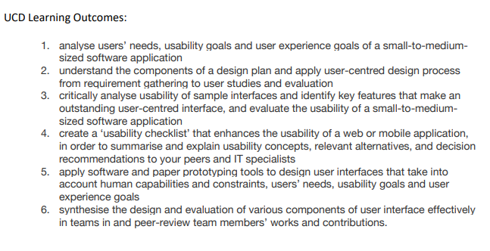

*Figure 1: The UCD Learning Outcomes*

# **What need to be prepared:**

## **3.1. The importance of theory of each Outcome**

### **3.1.1. Learning outcome 1**

**Outcome 1:** analyse users’ needs, usability goals and user experience goals of a small-to-medium sized software application.

UCD is a repetitive design process that concentrates on the user and their expectations and objectives in every developing operation stage (Babich 2019). It considers the client's demand and feedback which enables the definition of the fundamental requirements. Defining the user's need/goals/experience goals is the first step to take into analysis and compare what they need to the original design prototypes.

***Method***

Analyzing the User's Requirement is a repetitive manner to define user demands for our products, which are alternative and adjusted. The process encompasses a whole task of defining the directions of stakeholders. Hence, the process is to analyze, certificate, verify and control the application (Simplilearn 2020). The fundamental for the implementation of various user's need practise is an uncomplicated system including four stages:

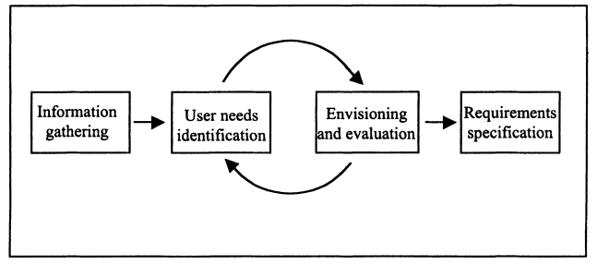

*Figure 2: Generic rule for user requirements analysis (Maguire & Bevan 2002)*

* Information gathering: collect and synthesize the information of the intended user and stakeholders divided into group users.
* User identification: Implement common methods for identifying user needs such as survey, groups, interview, Scenarios, Use-cases and Personas (Ux design - Research and insight 2017).
* Envision and evaluation: Sketch or make an artifacts design product for getting feedback.
* Requirement specification: set goals and measured the benchmark compared to the original and the prototyping.

***The importance***

The process of analysing user needs is an essential step due to t outlining what the user expects. It contributes all data required to **produce a scheme to satisfy the customer's demand**. Furthermore, the URS (Usability specification) also seems like a standard against mismatch prototyping (Wilson 2015).

In detail, the design team would explicitly define which function the filter has to be modified for friendly usability. The analysing process influences the performance of the redesign process (prototyping) directly.

It's recommended to pay attention to user elicit via survey, group, and interview and use the simulation to blueprint the user demand. It also enhanced potency, improved property activity, decreased maintenance and coaching expenses and gained user reward *(Maguire & Bevan 2002).*

### **3.1.2. Learning outcome 2**

**Outcome 2:** understand the components of a design plan and apply user-centred design process from requirement gathering to user studies and evaluation

A design plan in any Usability experience research project plays an essential role and seems like a solid framework in which to install the objectives and information to stakeholders and customers (UXPin 2020). The plan offers a design team to-do list for keeping track of the status in the process. Therefore, comprehending the planning scheme leads to smoothly and accurately applying the UCD from the demand gathering.

***Method***

All software and applications have their unique characteristics; therefore, the design plan has irregularities in construction and content. However, they all have the main structure with six phrases:

All software and applications have their unique characteristics; therefore, the design plan has irregularities in construction and content. However, they all have the main structure with six phrases:

* Team mission and statement: the purpose and the research topic.
* Project detail: the research topic, process and context.
* User requirement: goals, experience goals
* Functional requirement: the functions and features to satisfy the user's need.
* Data flow and workflow diagram: Reflect a work sequence for user task
* Prototype artifact: screenshot or sketch a new version.

Besides, the plan has to ensure document adequate delivery timing, to-do list, schedule, each team member's role, user scenario, tasks.

***The importance***

The research plan outlines the structure and clarifies each task of each step with carefully expected timing. The proposal allows stakeholders in charge of following and monitoring in the centre of the project. The design plan engages to be committed from the initial stage.

The plan is considered as a device to communicate what goal either for the design team or clients. It minimizes the opportunities to miss or forget any requirement feature or user request as a big picture that reflects the roadmap for development.

Understanding each element of the design plan means the operation can run smoothly and accurately. There is nothing to be confused or be missed during the repetitive process due to the roadmap's clarity. Prototyping strategy and evaluation process precisely take place.

### **3.1.3. Learning outcome 3**

**Outcome 3:** critically analyse usability of sample interfaces and identify key features that make an outstanding user-centred interface, and evaluate the usability of a small-to-medium- sized software application

Usability is considered an essential feature placed in multiple classifications (Boehm 1978). Despite the fact that it is a challenge to define a benchmark of usability, it's provided with the most widespread issues related to learnability and memorability of system, ease of use, the capability to recognize making a mistake and user's settlements (Neilsen, 1993). Hence, identifying the potential problematic feature and an unlogic interface layout through usability analysis delivers an excellent user-centred interface.

***Method***

Cognitive Walkthrough (Polson et al. 1992) and the Heuristic Nielsen (Nielsen 1992) principle are both well-known methods to analyze usability. The cognitive method is a process surrounding answering four questions with a task scenario. Besides Heuristic evaluation, there is an analysis among UI layout and ten laws.

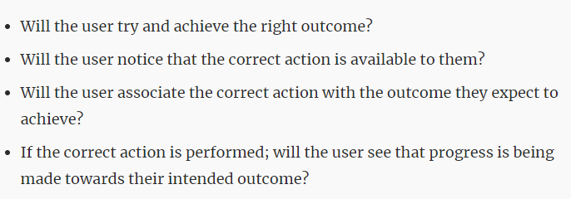

*Figure 3: Four question during a cognitive walkthrough*

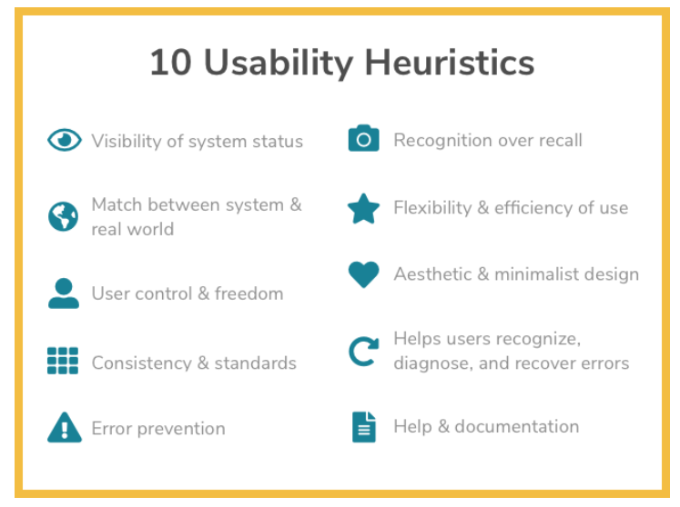

*Figure 4: Ten principles Heuristics.*

***The importance***

Having the abilities and skills to critically explain the usability of instant layout not only assists in determining the more optimized design interface but also enhances user performance.

Enhances awareness by simplifying multiple duties: The more complex task, the more requirement of various actions to perform. It creates difficulty for the user to remember what they have to execute. Diminishes on-the-job errors: having a minor task means having less possibility to make mistakes.

This step takes an essential role in defining and taking actions for the prototyping step. It's the premise for analysing and redesigning life cycles. The more interface samples have been discussed, the more usability experience in this process.

### **3.1.4. Learning outcome 4:**

**Outcome 4:** create a ‘usability checklist’ that enhances the usability of a web or mobile application, in order to summarise and explain usability concepts, relevant alternatives, and decision recommendations to your peers and IT specialists.

The vital point proportion to assess the goodness and convenience of mobile application (Inostroza et al. 2016) or web is identified as Usability. It saw the rise of desire in examining the evaluation method that assesses Usability. Besides, the Usability checklist presents the components and attributes for the evaluator to discover most usability problems.

***Method***

The subsequent checklist can be applied to immediately verify if the website satisfies the essential elements for immeasurable usability. For example:

|  |  |  |  |
| --- | --- | --- | --- |
|  | **Element** | **✓** | **Comment** |
| 1 | Loading time fewer than 2 seconds |  |  |
| 2 | Precise contrast |  |  |
| 3 | Font size and spacing is proper |  |  |
| 4 | Tidy pattern |  |  |
| 5 | Mobile website is quickly attainable |  |  |
| 6 | A tagline is ready and renders the side |  |  |
| .. | ... |  |  |

The subsequent checklist can be applied to immediately verify if the mobile application satisfies the essential elements for immeasurable usability. For example:

|  |  |  |  |
| --- | --- | --- | --- |
|  | **Element** | **✓** | **Comment** |
| 1 | Navigate easily |  |  |
| 2 | Precise and constant direction to go back on each screen |  |  |
| 3 | Font size and spacing is proper |  |  |
| 4 | Tidy pattern |  |  |
| 5 | Notice users amidst a verification decision meanwhile deleting. |  |  |
| 6 | Error messages precisely describe whence to punish the difficulty |  |  |
| .. | ... |  |  |

***The importance***

The usability checklist highlights the standard element and opinion for the evaluator during the testing process, which are implemented for mobile application and website. The objective of this method is to reveal a "must-have usability" (Jokela et al. 2004) in which to assess layout strategy and figure out the inherent issue.

Diminishing considerable expenses in the long-term by using a usability checklist, the developing team enables to save more time. The timing property utilizes to define the problem early and concede to alter various of the inherent layout.

### **3.1.5. Learning outcome 5**

**Outcome 5:** apply software and paper prototyping tools to design user interfaces that take into account human capabilities and constraints, users’ needs, usability goals and user experience goals.

Prototyping is a crucial part of the development and editing product interface. A prototype has seemed as a result of the prototyping process, which is a pre-product exhibition of remarkable perspective regarding a notion or definitive intention. Applying software or paper prototyping methods to get user feedback’s behaviour is a key for observation and getting insight to continuously develop a product.

***Method***

The opportunity to figure out the objects and the edit details is an effective means of interacting with stakeholders, customers, and the corresponding department about the manner that our function and feature work together. It depends on the extent and funds of the project that we can make a choice of the prototyping methods. There are many tools to execute the product design: static, clickable, paper and digital software.

Take paper prototyping as an example, sketching screenshots that present on paper being replacements for software illustration is the paper prototyping process. The common primary document archetypes are descriptions of any screen. In a presentation of either usability inspection, those figures imply shifts according to user behaviours. The process can be viewed and take preference here by this link: <https://www.youtube.com/watch?v=GrV2SZuRPv0>

***The importance***

Through prototyping tools, designers have a chance to observe marine components and associate them to provide a stable layout of the appearance of the design. It seems like an indispensable method for every UI and UX product due to the importance of collecting feedback, evaluating usability, and updating the interface for the long term.

The prototyping process enormously minimizes the burden and volume in evolving the usability process, decreasing the expense. Besides, the designer directly gets feedback from end-users through observing the behaviour of them with their outcomes. It importantly presents how the outcomes look and allows the whole team to arrange and adjust concentrates on the interface.

### **3.1.6. Learning outcome 6**

**Outcome 6:** synthesise the design and evaluation of various components of user interface effectively in teams in and peer-review team members’ works and contributions.

After planning and procurement prototypes for the original application/web, executing evaluation is the following essential part. Integrating the intended outcomes and assessing various user interface components is a key to collecting raw data for the designer and evaluator. From the raw data collected, it's necessary to deliver it to valuable insight and easy-to-read data.

***Method***

In UCD, an inter-professional collaborative process of sensemaking is the synthesis that prompts a unified version of the complete collected information while designing (Baylé 2018). It concludes for three rounds:

* Step 1: exteriorize the whole information collected to lead the team feeling available to alter and adjust.
* Step 2: Coordinating the results of the outcomes in the models or themes.
* Step 3: Determining and synthesizing the groups and connections to deliver an understandable and instructors.

From the data collected by the synthesizing stage, the data collected by the synthesizing stage enables it to be compared in the evaluation process. It compares the outcomes of design products to the original ones and the usability specifications. From there, the outcome's performances can comprehend whether it's adequate and adaptive to the user's requirement.

***The importance***

According to Jones, a good design process is evaluated by analysis, synthesis, and evaluation (ASE) (Jones 1963). The synthesis process guarantees to combine, arrange, filter, and consider crucial erudition and restrictions for the intention clarification.

Employees operating in teams have a tendency to receive a majority chance to illustrate more immeasurable maintenance than working individually. Therefore, having a structure to evaluate wherewith to expedite it and assess the performed operation is essential. They can evaluate the productivity and efficiency of the work through peer evaluation. From there, draw lessons and experiences for the next process.

## **3.2. How the outcomes related together**

To summarize, the above six outcomes represent a user-centred design process that the course assumes learners can implement to current projects and future careers. Six outcomes reflect sincerely from collecting user demands to analyze the behaviours and capabilities that the application/website can prompt difficulties for users. Produce a secure plan for the steps in the process so that no stage is missed. Create a checklist for the interface product analysis and evaluation process. Suddenly apply remarkable software engineering methods to the prototyping process, which is a process of delivering the design output. From there, observe and collect data from the user's behaviour in the process of using the new finished product. Finally, synthesize and analyze those insights to determine whether prototyping is effective or not. Determine the objectives for the design circle process.

Missing or not acknowledged performance in one of the above steps will diminish the quality of the design process because each of the above steps initiates the stage for the subsequent step that complies. For example, suppose the customer requirement is not entirely defined. In that case, the fundamental requirement cannot be determined, and the useability specification is also incorrect because the measured data obtained in the process will be linked and directly affect each other.

# **A guide to success in User Centred Design course:**

For success in this course, the student may work out to comprehend and practise *section 3: What to be prepared.* The report notes all-important keys and values for this course which assist the learner to keep track of what they have completed during the learning process. Although having a good mark enables you to reflect how much effort you put, acquiring these six outcomes is much more valued. Evidence for this course's success is that students finally know what they learn would apply to their future career. A few tips that you can use during your study road that make you find more easier:

* Acquire yourself to identify yourself as a thinker and learner.
* Installed an individual object for any program.
* Time management and Attendance.
* Think and work as an expert.
* Examine notes asap and research any curiosity.
* Make a limited practice toward an assignment, optionally outlining out a plan or framework for completion.
* Sharing a challenging thought, concept, obstacle with your teammate.

# **Reference list**

Abras, C., Maloney-Krichmar, D. and Preece, J., 2004. User-centered design. Bainbridge, W. Encyclopedia of Human-Computer Interaction. Thousand Oaks: Sage Publications, 37(4), pp.445-456.

Babich, N 2019, 'User Centered Design Principles & Methods', *Adobe*, 18 October, viewed 24 May 2021. <<https://xd.adobe.com/ideas/principles/human-computer-interaction/user-centered-design/>>

Simplilearn, 2020, *What Is Requirement Analysis: Overview, Applications, Techniques and Top Tools Used*, 2 December, viewed 24 May 2021. <<https://www.simplilearn.com/what-is-requirement-analysis-article>>

*Maguire*, M, Bevan, N, 2002, *User Requirements Analysis*, Springer, Boston, MA.

Wilson, M 2015, *Implementation of Robot Systems: Specification Preparation,* Butterworth, Heinemann.

Ux design - Research and insight, U 2017, *Personas, scenarios, user stories and storyboards: what’s the difference?, 28 Jul, view 24 May 2021. <*<https://www.justinmind.com/blog/user-personas-scenarios-user-stories-and-storyboards-whats-the-difference/>>

UXPin, 2020,’Creating A User Research Plan (with Examples)’, Studio by UXPin, 8 October, viewed 24 May 2021 <<https://www.uxpin.com/studio/blog/ux-research-plan/>>

Boehm, B 1978, *Characteristics of Software Quality,* North Holland, New York.

Nielsen, J 1992, *Usability Engineering*, AP Professional, Boston, MA.

Polson, PG, Lewis, C, Rieman, J, Wharton, C 1992, *Cognitive walkthroughs: a method for theory-based evaluation of user interfaces,* International Journal of man-machine studies*.*

Inostroza, R, Rusu, C, Roncagliolo, S, Rusu, V & Collazos, C 2016, *Developing SMASH: a set of smartphone's usability heuristics*, Computer Standards & Interfaces.

Jokela, T, Iivari, N, Matero, J, & Karukka, M 2003, *The standard of user-centered design and the standard definition of usability: Analyzing,* Proceedings of the Latin.

Kolko, J 2010, *Abductive Thinking and Sensemaking: The Drivers of Design Synthesis*, In MIT's Design Issues, vol 26, No.1 Winter.

Baylé, M 2018, Synthesis: How to make sense of your design research, *UX Collective,* 16 May, viewed 25 May 2021. <<https://uxdesign.cc/synthesis-how-to-make-sense-of-your-design-research-d67ad79b684b>>

Jones, C 1963, "A Method of Systematic Design", C*onference on Design Methods*, Pergamon, Oxford.